Python Lab Assignment-2

Name: Saketh Garuda

ID: 16

## Objective:

The main objective for this lab assignment is to know the working of sets, dictionaries and ability to create back end web applications in python. By using the above methods we met the following objectives,

* To find the desired information in the given range using dictionaries
* Able to update and lookup dictionaries
* Usage of classes and OOPS concepts in python
* Using numpy library to find the most frequent item in the list

## Features:

The code snippets are executed and debugged for purpose of software environment. The code snippets are written in such way that they won’t affect the performance of the system when they are executed in multiple envirmonents.

## Configuration:

* PyCharm IDE
* Python 3.6.4

## Screenshots:

1) To find the books in the range given by the user

## Output:

* Books which are in the range are printed accordingly,

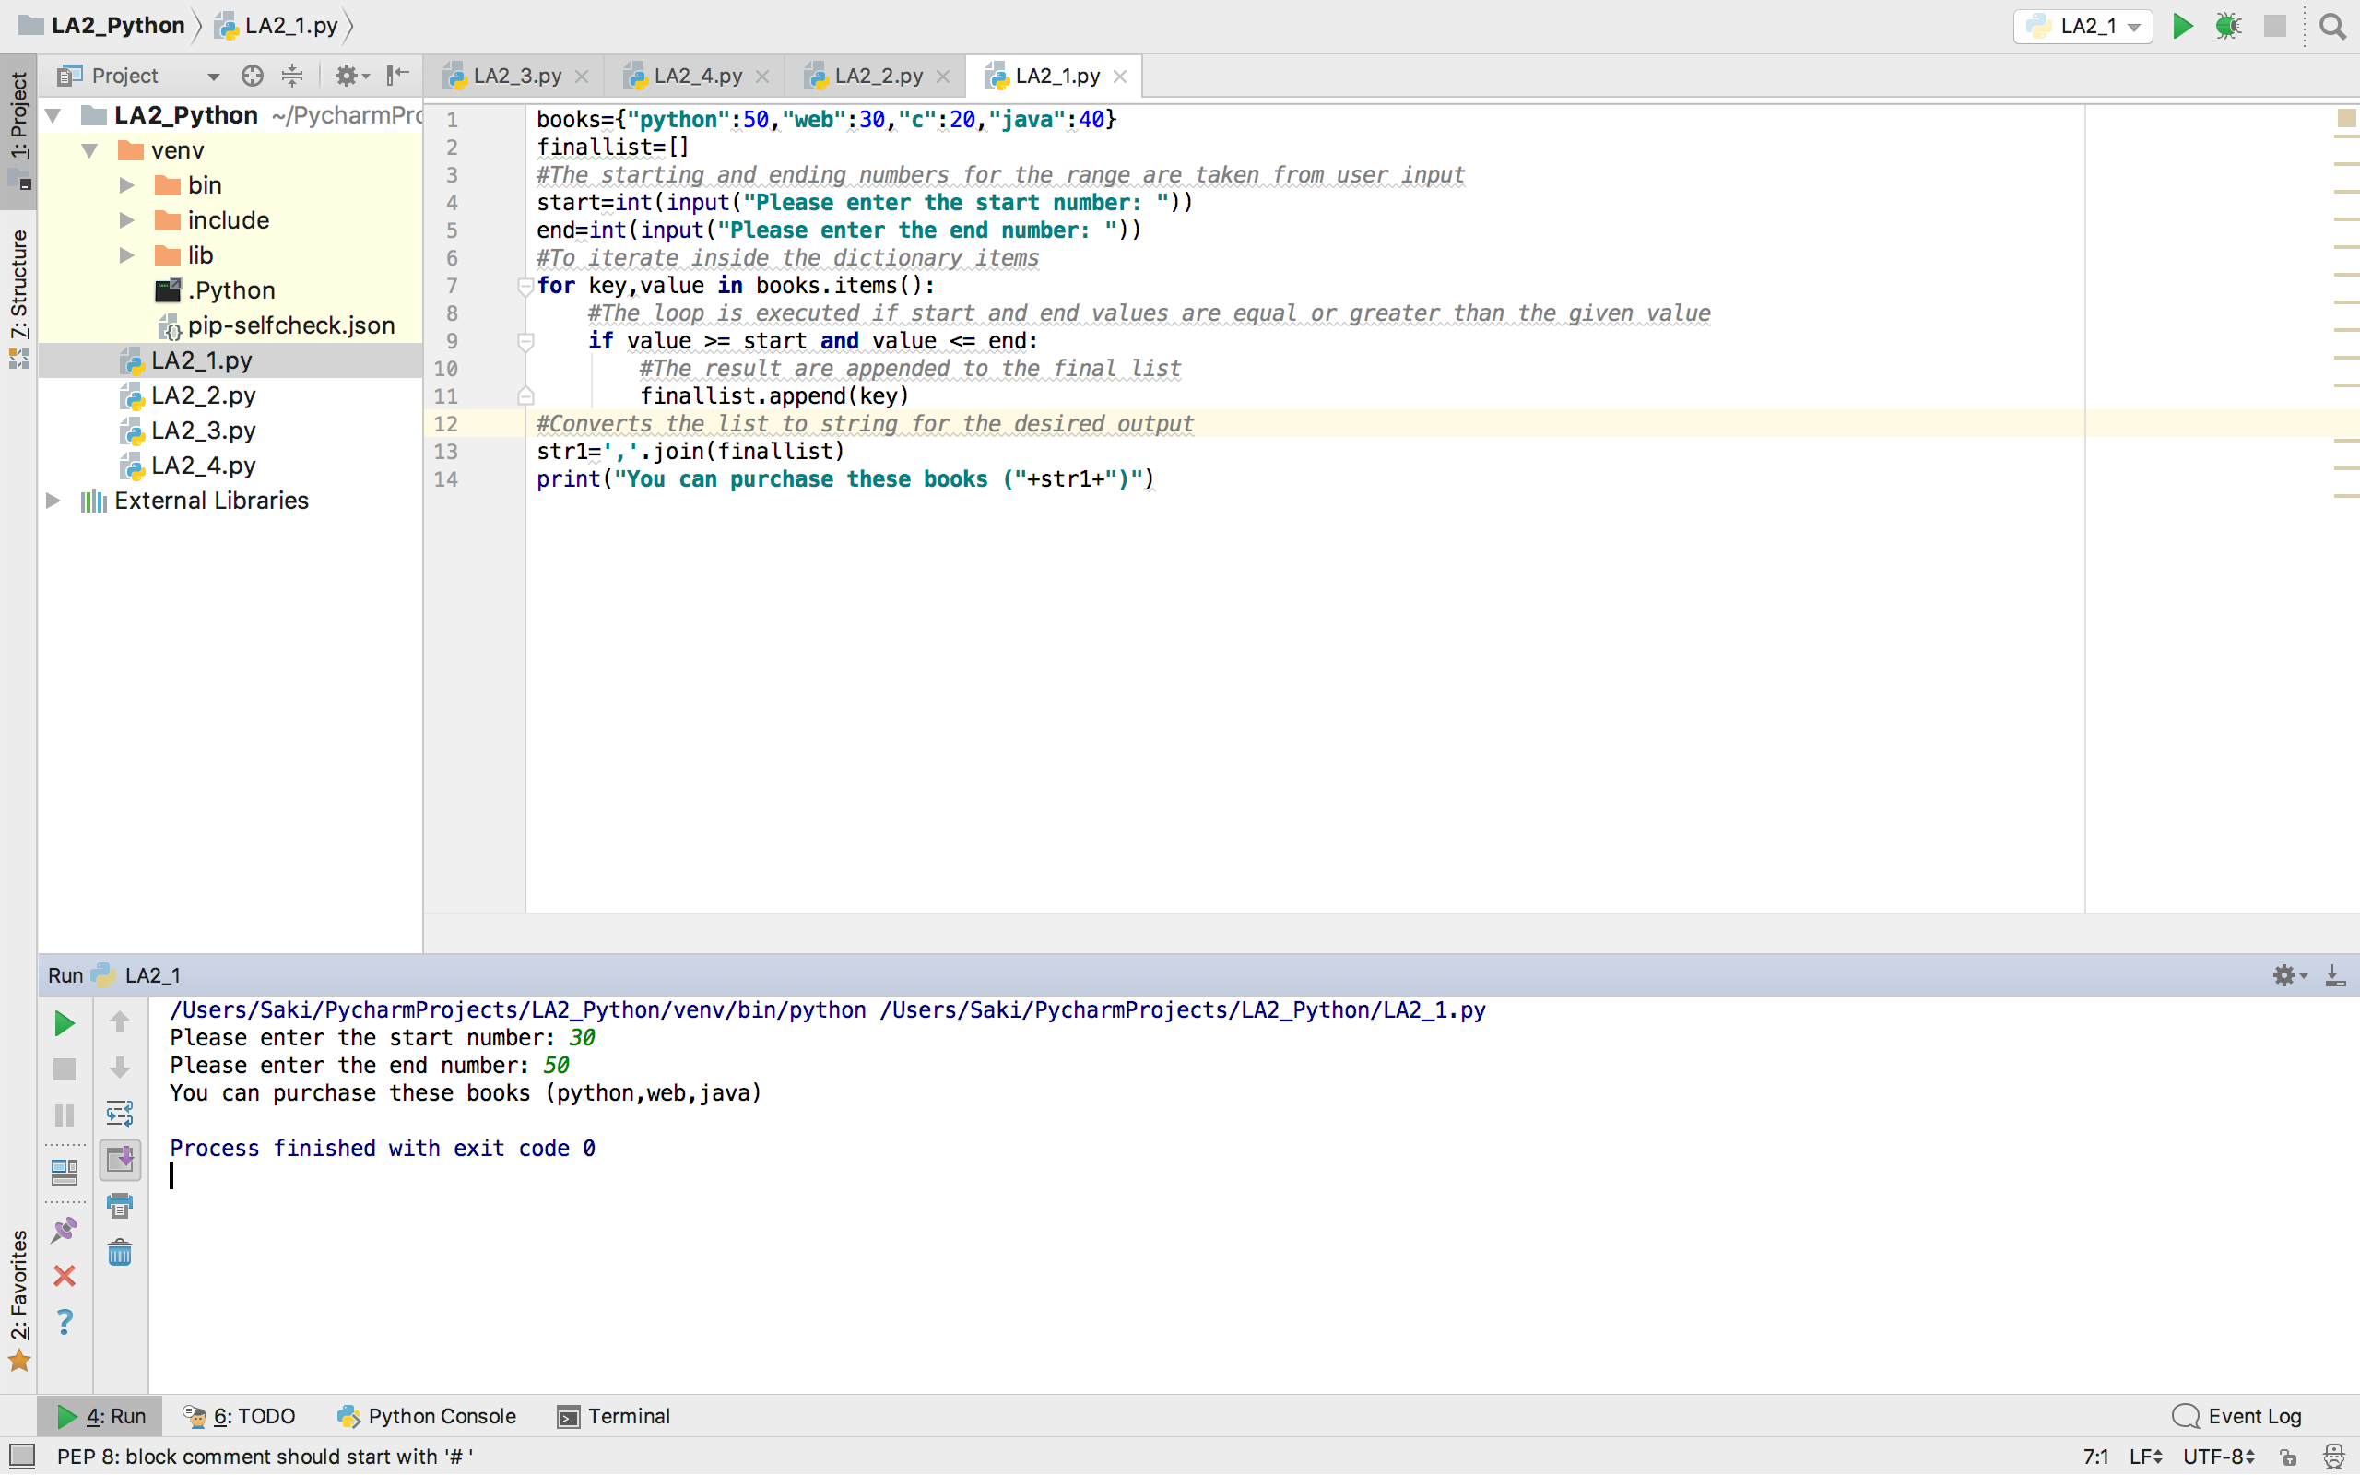

2) Create a list of contacts and prompt the user for following,

a) Display contact by name

b) Display contact by number

c) Edit contact by name

d) Exit

## Output:

* When option ‘a’ is entered the contacts by name are displayed,

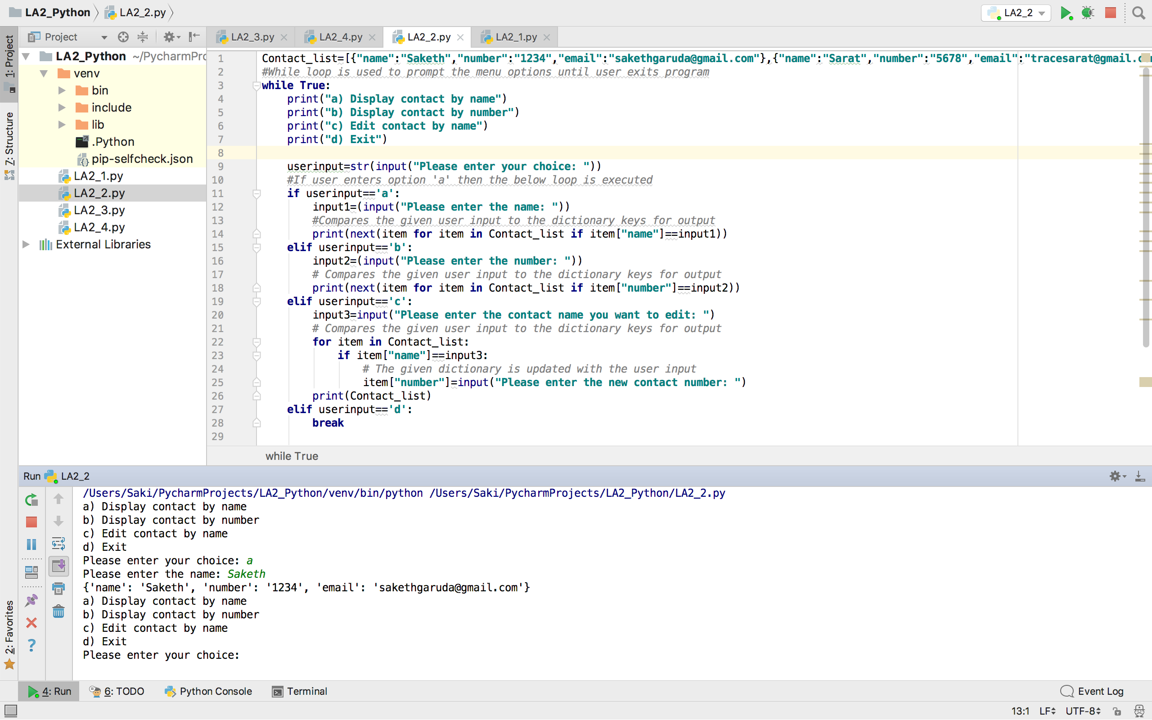

* When option ‘b’ is entered the contacts by numbers are displayed,

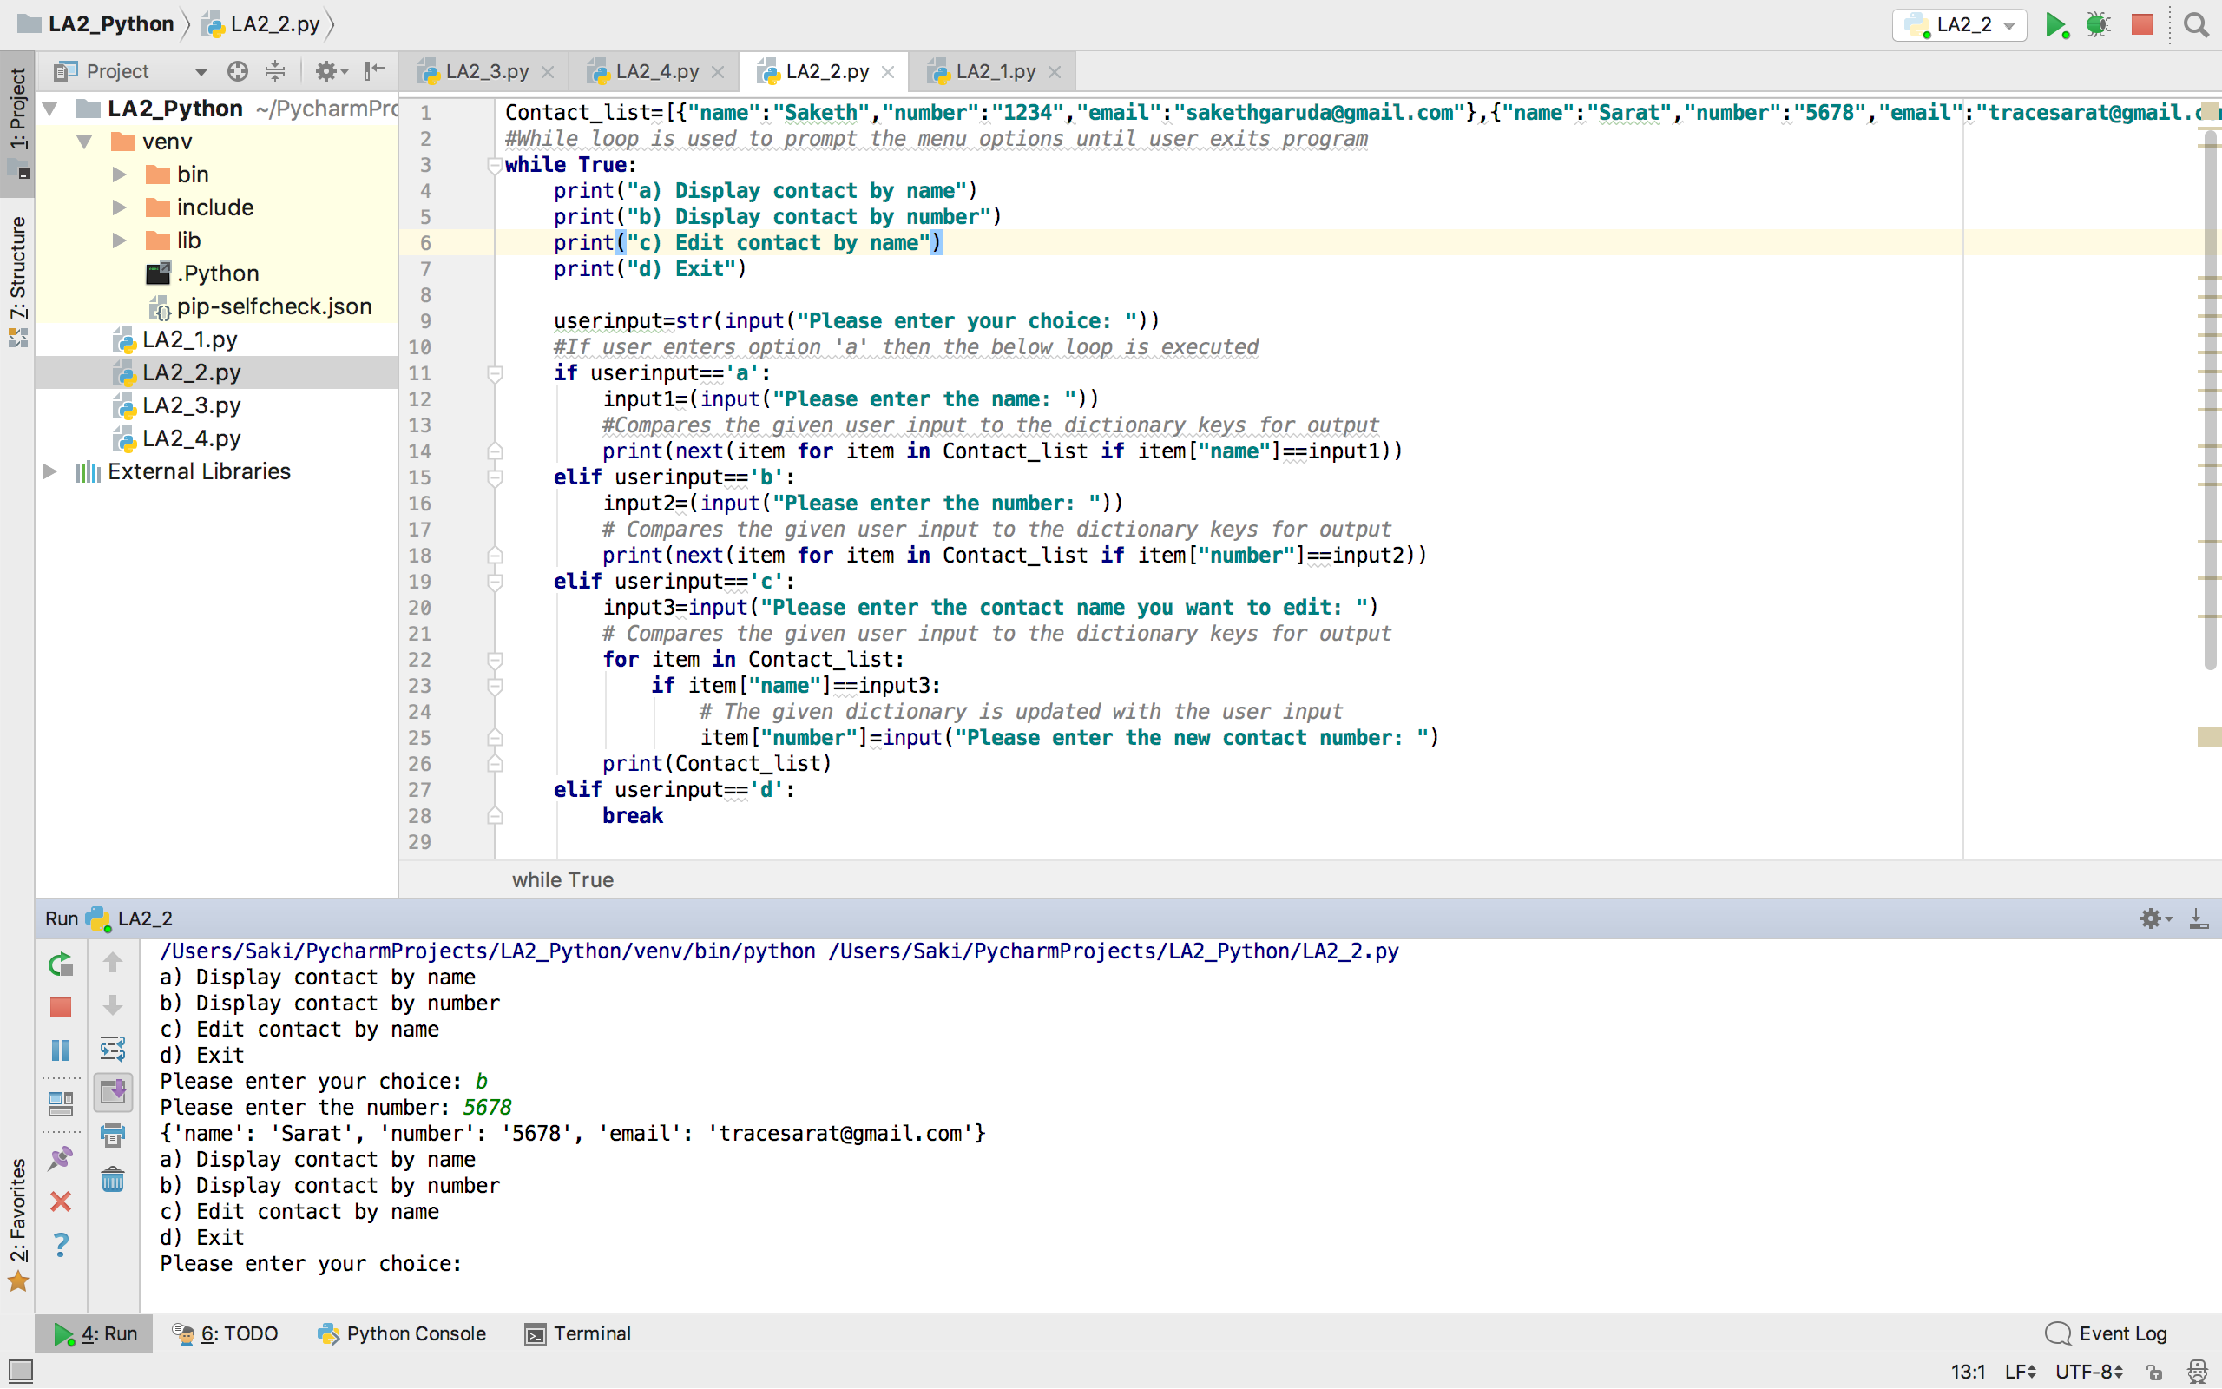

* When option ‘c’ is entered the user is prompted for contact name and to enter the new number for desired contact

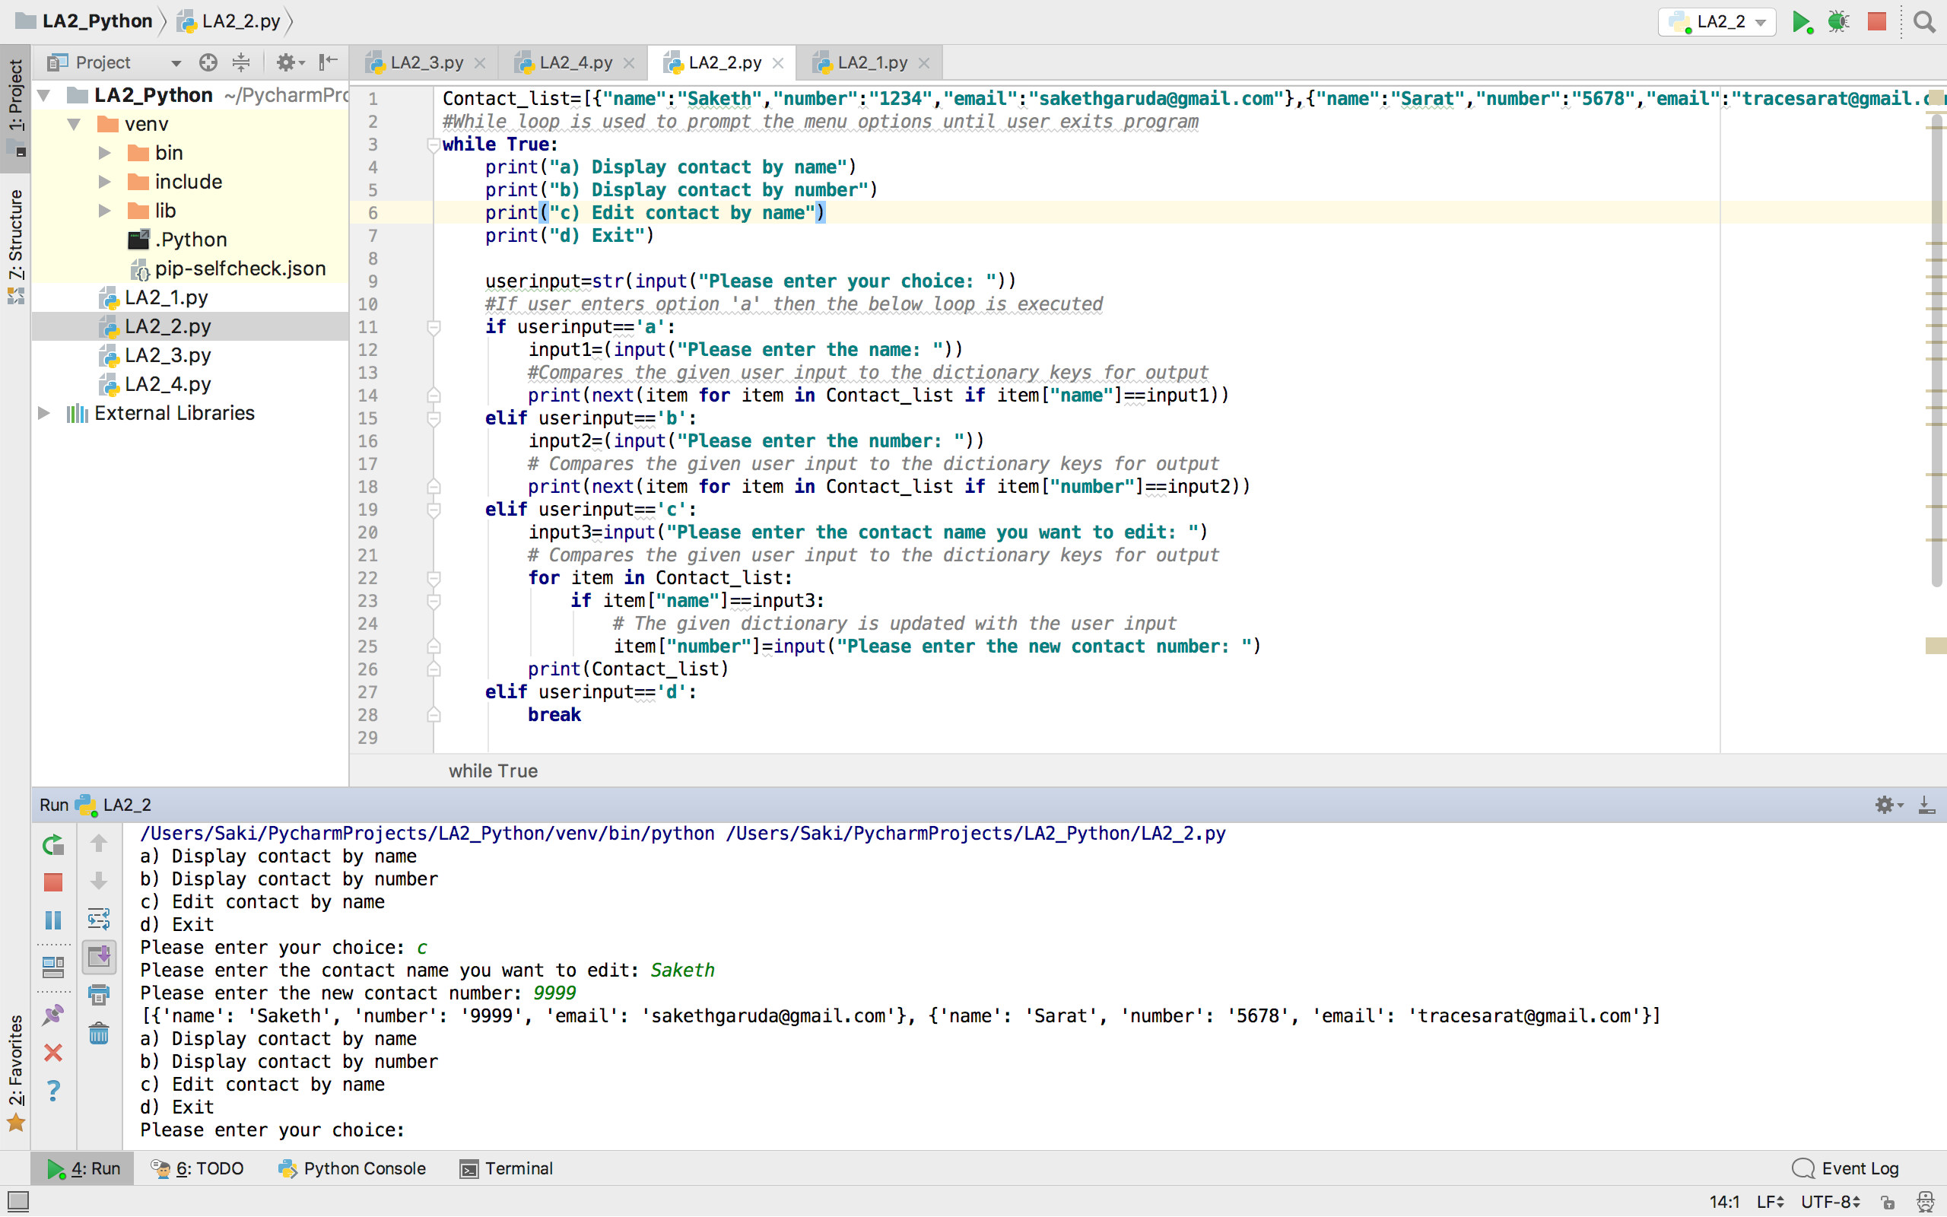

3) Write a python program to create any one of the following management systems. You can also pick one of your own.

a.Library Management System (should have classes for Person, Student, Librarian, Book

etc.)

b.Airline Booking Reservation System (classes for Flight,Person,Employee,Passenger etc.)

c.Hotel Reservation System (classes for Room,Occupants,Employee etc.)

d.Student Enrollment System (classes for Student,System,Grades etc.)

e.Expense Tracker System (classes for Expense, Transaction Category etc.)

## Output:

* Library Management system is implemented.

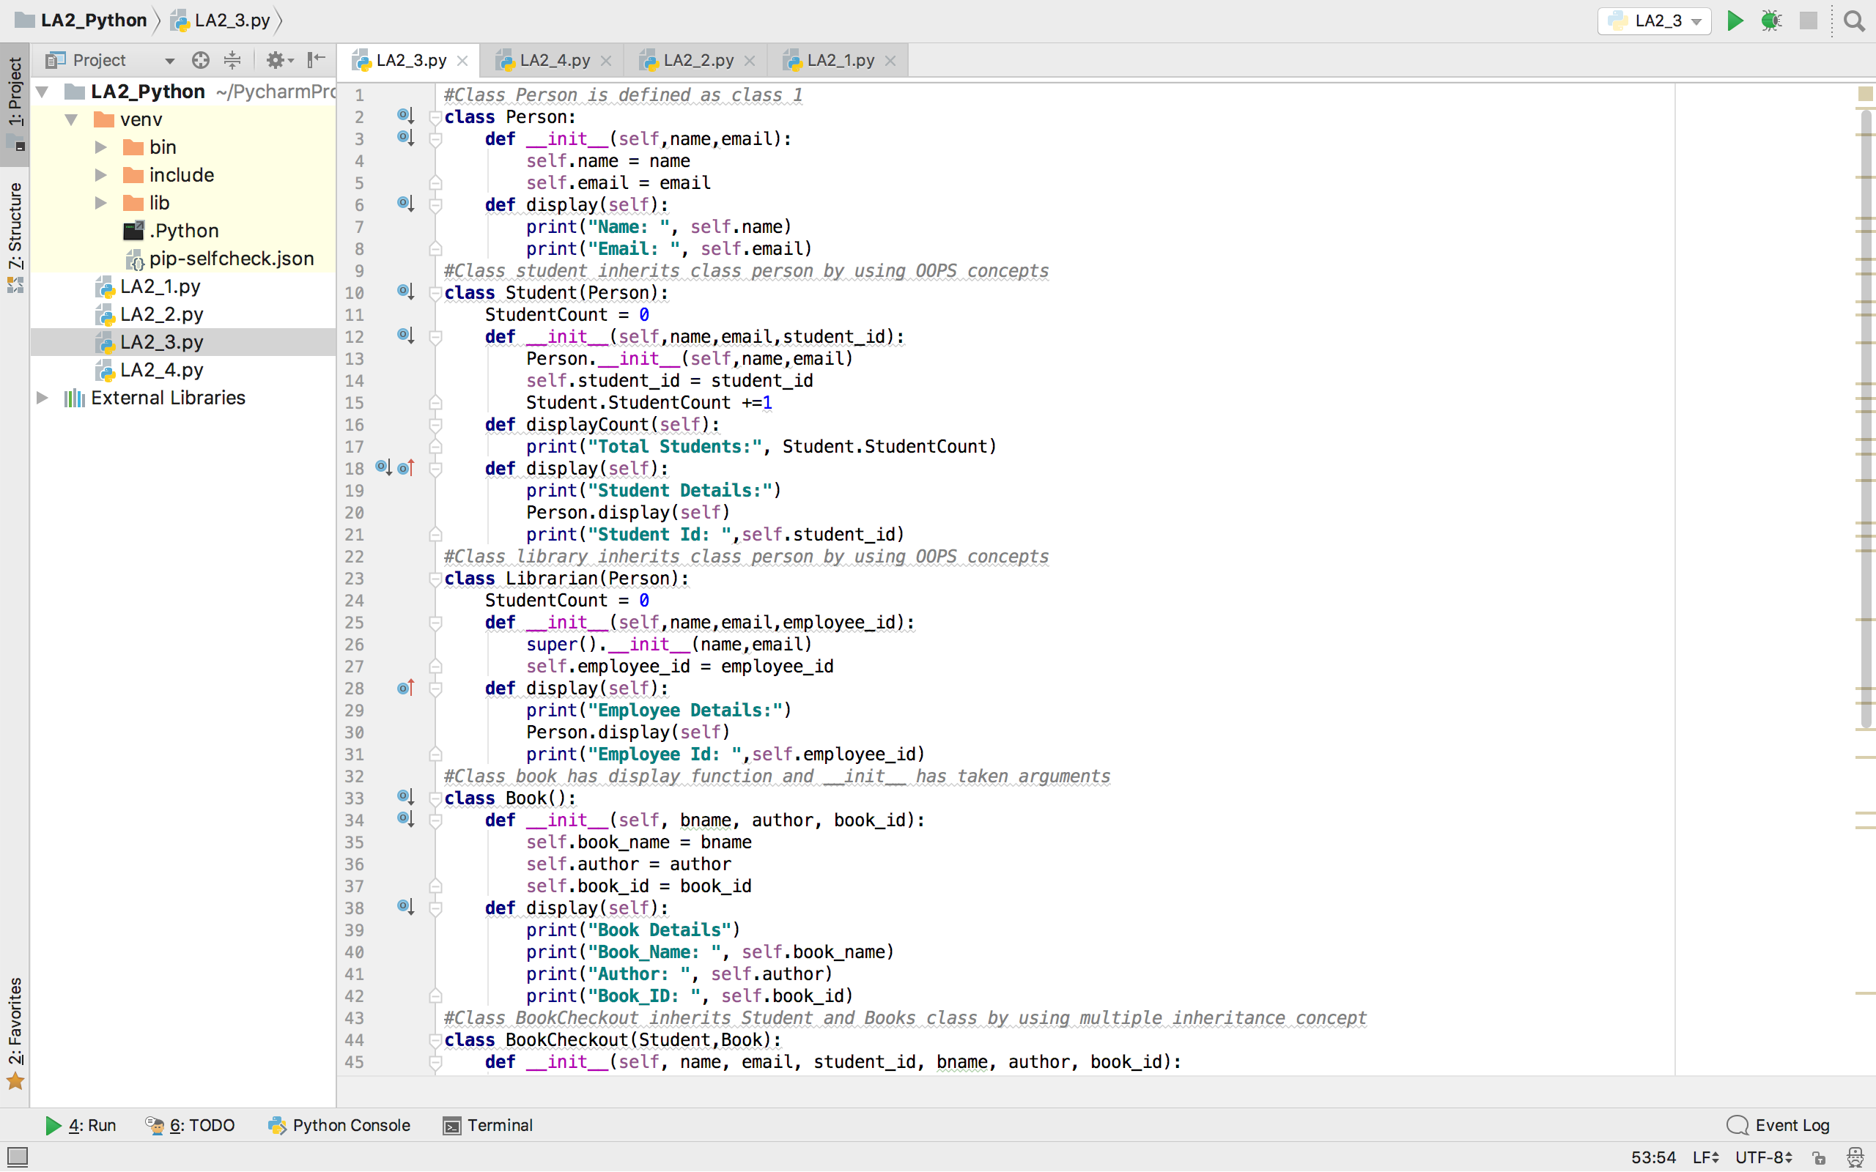

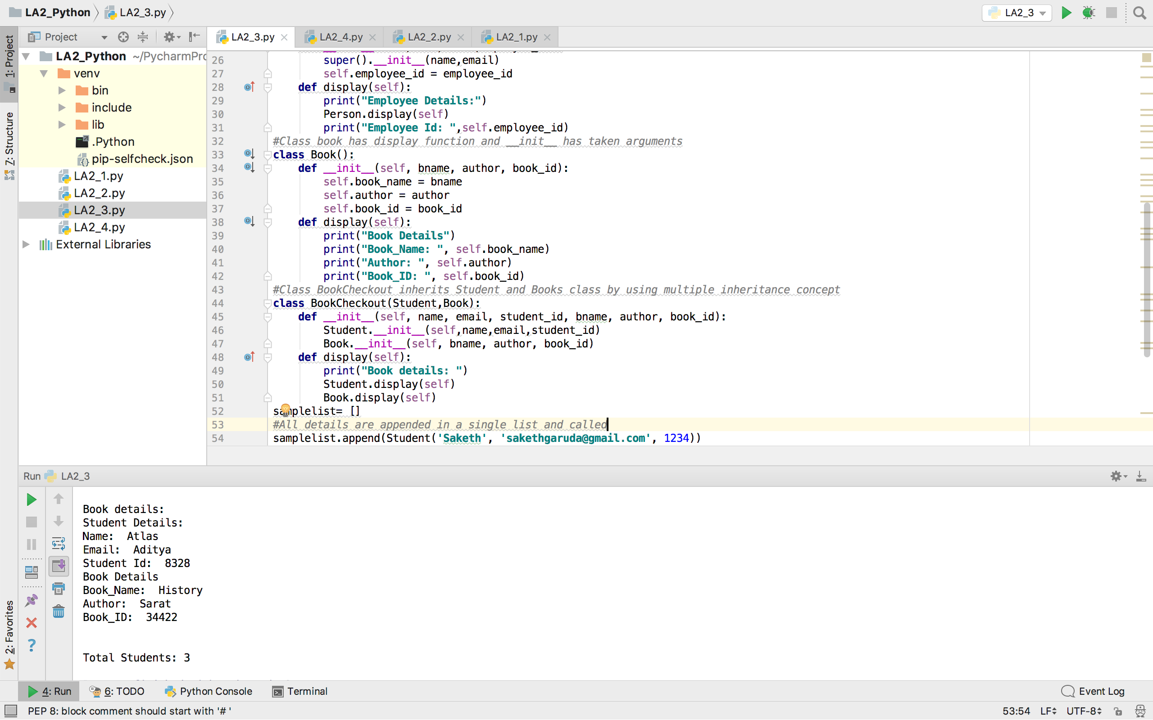

4) Using Numpy create random vector of size 15 having only Integers in the range 0 -20. Write a program to find the most frequent item/value in the vector list.

## Output:

* The most frequent item in the vector list is printed using argmax method.

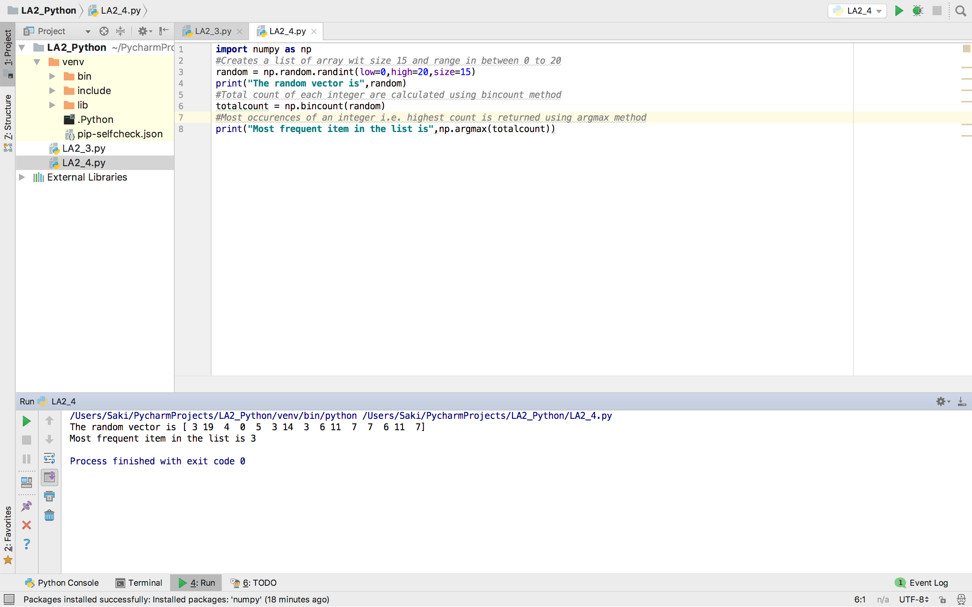

## Code Snippets:

## Code Snippet 1:

books={**"python"**:50,**"web"**:30,**"c"**:20,**"java"**:40}  
finallist=[]  
*#The starting and ending numbers for the range are taken from user input*start=int(input(**"Please enter the start number: "**))  
end=int(input(**"Please enter the end number: "**))  
*#To iterate inside the dictionary items***for** key,value **in** books.items():  
 *#The loop is executed if start and end values are equal or greater than the given value* **if** value >= start **and** value <= end:  
 *#The result are appended to the final list* finallist.append(key)  
*#Converts the list to string for the desired output*str1=**','**.join(finallist)  
print(**"You can purchase these books ("**+str1+**")"**)

## Code Snippet 2:

Contact_list=[{**"name"**:**"Saketh"**,**"number"**:**"1234"**,**"email"**:**"sakethgaruda@gmail.com"**},{**"name"**:**"Sarat"**,**"number"**:**"5678"**,**"email"**:**"tracesarat@gmail.com"**}]  
*#While loop is used to prompt the menu options until user exits program***while True**:  
 print(**"a) Display contact by name"**)  
 print(**"b) Display contact by number"**)  
 print(**"c) Edit contact by name"**)  
 print(**"d) Exit"**)  
  
 userinput=str(input(**"Please enter your choice: "**))  
 *#If user enters option 'a' then the below loop is executed* **if** userinput==**'a'**:  
 input1=(input(**"Please enter the name: "**))  
 *#Compares the given user input to the dictionary keys for output* print(next(item **for** item **in** Contact_list **if** item[**"name"**]==input1))  
 **elif** userinput==**'b'**:  
 input2=(input(**"Please enter the number: "**))  
 *# Compares the given user input to the dictionary keys for output* print(next(item **for** item **in** Contact_list **if** item[**"number"**]==input2))  
 **elif** userinput==**'c'**:  
 input3=input(**"Please enter the contact name you want to edit: "**)  
 *# Compares the given user input to the dictionary keys for output* **for** item **in** Contact_list:  
 **if** item[**"name"**]==input3:  
 *# The given dictionary is updated with the user input* item[**"number"**]=input(**"Please enter the new contact number: "**)  
 print(Contact_list)  
 **elif** userinput==**'d'**:  
 **break**

## Code Snippet 3:

## Code Snippet 4:

**import** numpy **as** np  
*#Creates a list of array wit size 15 and range in between 0 to 20*random = np.random.randint(low=0,high=20,size=15)  
print(**"The random vector is"**,random)  
*#Total count of each integer are calculated using bincount method*totalcount = np.bincount(random)  
*#Most occurences of an integer i.e. highest count is returned using argmax method*print(**"Most frequent item in the list is"**,np.argmax(totalcount))

## Deployment:

The code snippets are written using Python IDE and executed with the help of python 3.6.4 interpreter. Outputs are shown in the Python IDE console.

## Limitations:

The given code snippets doesn’t have any limitations as they have met all rules and conditions.

## References:

* <https://docs.scipy.org/doc/numpy/reference/generated/numpy.random.randint.html>
* <https://stackoverflow.com/questions/26823451/prompt-user-for-positive-number-and-continues-to-prompt-the-user-until-they-ent>
* <https://stackoverflow.com/questions/743164/emulate-a-do-while-loop-in-python>
* <https://wiki.python.org/moin/SortingListsOfDictionaries>